**Project Design Phase-II**

**Data Flow Diagram & User Stories**

|  |  |
| --- | --- |
| Date | 28 June 2025 |
| Team ID | LTVIP2025TMID56240 |
| Project Name | **ShopSmart** |
| Maximum Marks | 4 Marks |

**Data Flow Diagrams:**

A Data Flow Diagram (DFD) is a traditional visual representation of the information flows within a system. A neat and clear DFD can depict the right amount of the system requirement graphically. It shows how data enters and leaves the system, what changes the information, and where data is stored.

**Example:**

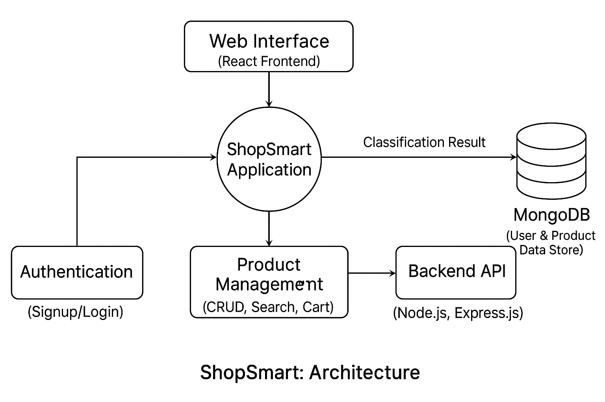

**User Stories**

| **Sprint** | **Functional Requirement (Epic)** | **User Story Number** | **User Story / Task** | **Story Points** | **Priority** | **Team Members** |
| --- | --- | --- | --- | --- | --- | --- |
| Sprint-1 | User Registration & Authentication | USN-1 | As a user, I can sign up and log in securely to access the platform.. | 3 | High | Bhavagna |
| Sprint-1 | Product Catalog | USN-2 | As a user, I can view a list of products with details like price, description, and images.. | 3 | High | Ampa Chaitanya Naga Durga Ganesh |
| Sprint-1 | Search & Filter | USN-3 | As a user, I can search products and apply filters like price, category, and ratings. | 4 | High | Boda Prasanna Venkata Siva Kumar |
| Sprint-2 | Cart Functionality | USN-4 | As a user, I can add or remove items from my shopping cart. | 3 | High | Ampa Chaitanya Naga Durga Ganesh |
| Sprint-2 | Order Placement | USN-5 | As a user, I can proceed to checkout and place orders using a simple flow | 4 | Medium | Bhavagna |
| Sprint-2 | |  | | --- | |  |   Payment Integration | USN-6 | As a user, I can make payments securely using online methods (e.g., Razorpay/UPI). | 5 | High | Boda Prasanna Venkata Siva Kumar |
| Sprint-3 | Order Tracking | USN-7 | As a user, I can track the status of my placed orders. | 2 | Medium | Bolla Geethika Naga Sai Sridevi |
| Sprint-3 | Admin Dashboard | USN-8 | As an admin, I can manage products, view orders, and handle inventory. | 4 | High | Bolla Geethika Naga Sai Sridevi |
| Sprint-3 | Product Recommendations | USN-9 | As a user, I can get smart product suggestions based on my search/purchase history | 3 | Low | Bolla Geethika Naga Sai Sridevi |
| Sprint-3 | Final Testing & Deployment | USN-10 | As a team, we want to test the complete app and deploy it to production. | 3 | High | All Members |